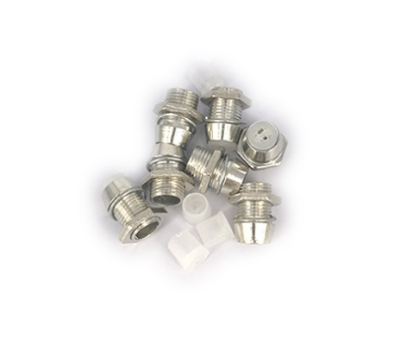
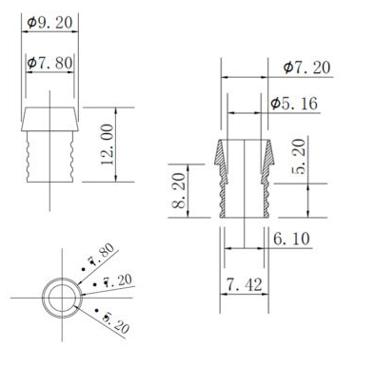
PARAMETERS
SPEC: F5 COPPER HOLDER
ITEM NO: HCS
MATERIAL: COPPER
MAIN FEATURES
FIRE RATING: 94V-2
REMARK: copper sleeve + Nut + plug(white)
Certification: RoHs

